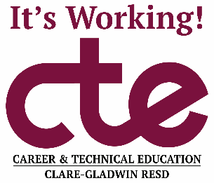

May 25th, 2023
Dear Parent/Guardian:

My name is Eric Johnson, and I am the CTE Director for Clare-Gladwin RESD. You are receiving this letter because your child has enrolled in a Career and Technical Education (CTE) class through the Clare -Gladwin RESD for the 2023-2024 school year. I congratulate your son or daughter on taking this exciting step to gain the skills and training needed to prepare for a career or college after high school graduation!

Our records indicate that your student is enrolled in:
Criminal Justice
Location: CTE Wing- Mid Michigan College
Program Instructor: Buddy Boylen
Contact Information: Phone (989) 386-9334 or email lboylen@cgresd.net

ALL CTE CLASSES WILL BEGIN TUESDAY, August 22nd. For the most part, the CTE calendar is similar to your student’s local high school calendar, but there may be dates where your student will be expected to attend CTE classes when your local high school is not in session. Please refer to your high school office for information about these dates. This class is part of your student’s regular high school schedule and will count for high school credit toward graduation. As with all classes, regular CTE attendance is crucial for successfully earning credit.

During the first week of school, your student will receive a packet of information and forms that need to be completed and returned to their CTE instructor. These forms include emergency contact information verification, CTE Student Handbook, a Technology Acceptable Use Policy, and directions for obtaining parent access to Skyward for CTE programs.

Research shows that students who attend CTE programs enjoy school more and graduate at higher rates than students who do not attend CTE. I am confident your student will also find this type of success and satisfaction in CTE. On behalf of the entire CTE staff, we are looking forward to helping them start on the path toward an exciting and rewarding future!

Sincerely,

Eric Johnson, CTE Director/Principal
The Clare-Gladwin Regional Education Service District Board of Education complies with all Federal laws prohibiting discrimination and with all requirements and regulations of the U.S. Department of Education. It is the policy of the Clare-Gladwin Regional Education Service District that no person on the basis of race, color, religion, national origin, creed or ancestry, age, gender, sexual orientation, marital status, or disability shall be discriminated against, excluded from participation in, denied the benefits of or otherwise be subjected to discrimination in employment or under any program or activity to which it is responsible, or for which it receives financial assistance from the U.S. Department of Education. For information contact the Superintendent at Clare-Gladwin Regional Education Service District, 4041 E. Mannsiding Rd, Clare, MI 48617 (989) 386-3851.

